Add DbContext Class to Infrastructure Layer

- Create Persistence folder
- Create class library name RestaurantsDbContext.cs
- Create DbSet
- Create connection to database (connectionstring)
- Run this command:
  - $ dotnet ef migrations add InitialCreate -p ./Restaurants.Infrastructure.csproj -s ../Restaurants.Api/Restaurants.Api.csproj
- Then will get this error:
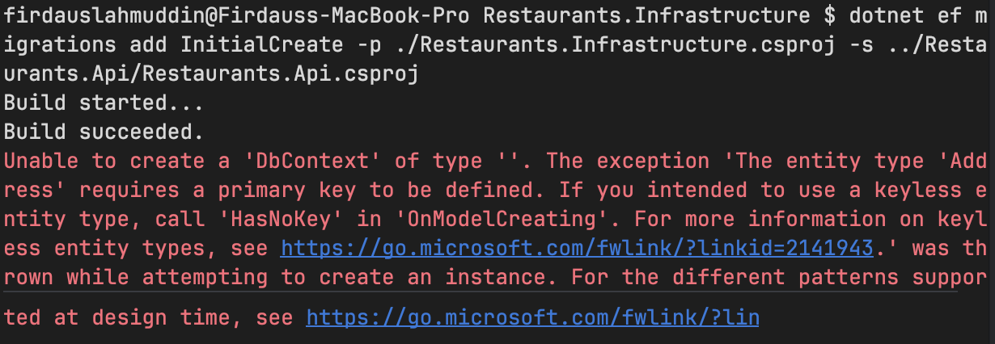
- This is because
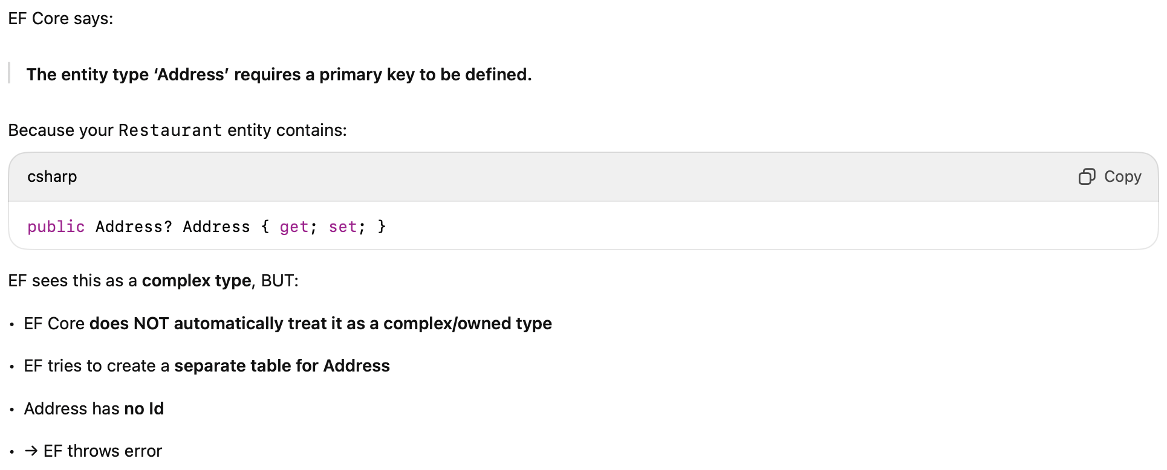

- So, we need to add below code in the DbContext using OnModelCreating:
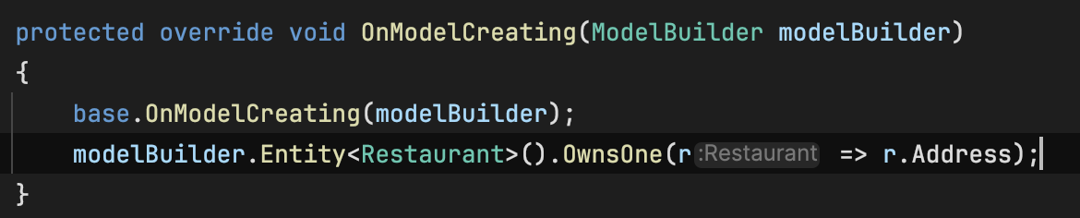
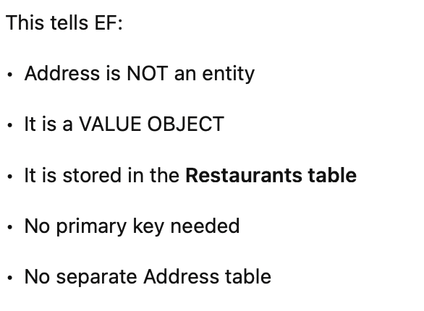
- Add another modelBuilder to talk about dish foreign id and the dish relationship
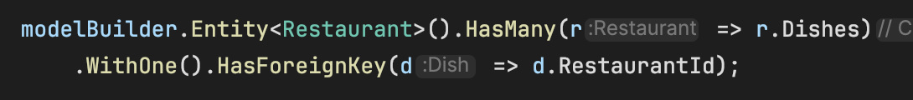

- Add RestaurantId in the dish.cs
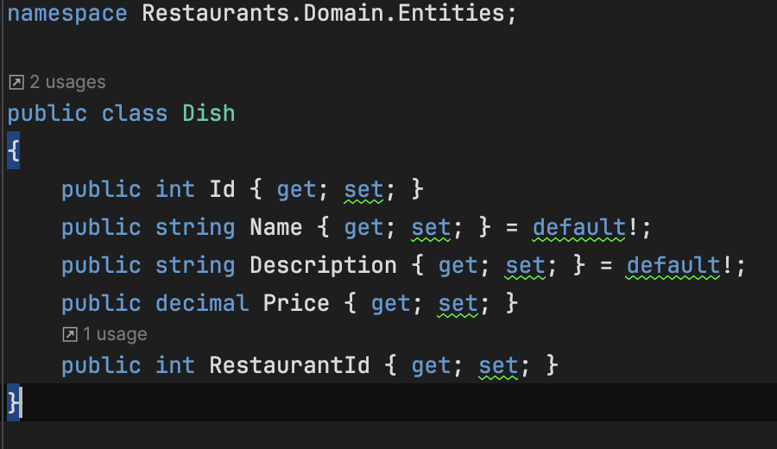
- Run this command again:
  - dotnet ef migrations add InitialCreate -p ./Restaurants.Infrastructure.csproj -s ../Restaurants.Api/Restaurants.Api.csproj
  - dotnet ef database update -p ./Restaurants.Infrastructure.csproj -s ../Restaurants.Api/Restaurants.Api.csproj
